Online Shopping System

Group Member: Duanduan Liu, Shaowei Gong, Yihan Bao

1. **Introduction**

Our online store system is an information management system, including front page, persistence layer back-end database and the business logic layer. Our online store includes two parts: the front-end user part and the back-end management part. Front-end part consists of user registration, goods-ordering, products-browsing, products information checking.

We use HTML to implement the frame of our web pages and use CSS and Ajax to polish our web pages. And use ORM layer in java to build up our database schema and connect our front-end webpage with database. Also we use MVC mechanism implemented by java to fulfill interactive websites which are corresponded in database.

1. **Software Development Environment**

Our software development environment is as following

Operation system: Windows 7

Web Server and JDK: Tomcat 7.0, JDK 1.8.0

IDE: Eclipse

Database: MySQL 5.5

1. **Websites pages design**

To implement the function mentioned above, we need 8 pages: Home page, productdetail page, shippingcart page, checkout page, contact page, faqs page and about page.

Home page: Home page lists the products provided by our online store and links turning into other pages. Our customer can add the products that they want to order directly from home page and learn details of products by clicking the images of products.

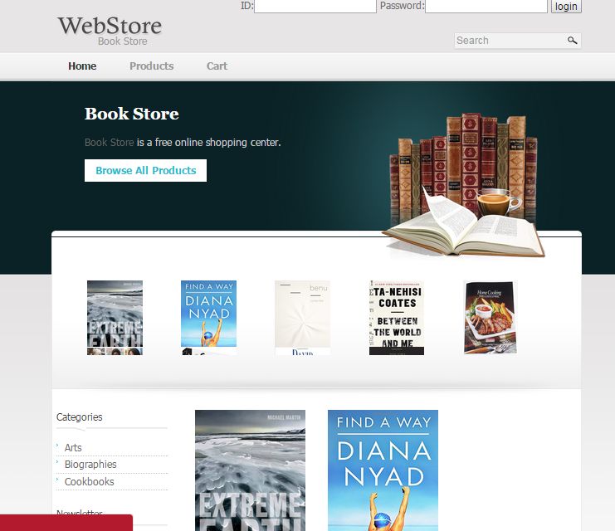

Productdetail page: products page lists detail information of one particular product, such as detailed description of products, consumers can select the size, amount of products etc. from this page. This page also displays related products.

Shoppingcart page: shoppingcart displays all products selected by one particular consumer, consumer can add or drop product from this page and also can choose to continue shopping or checkout from this page.

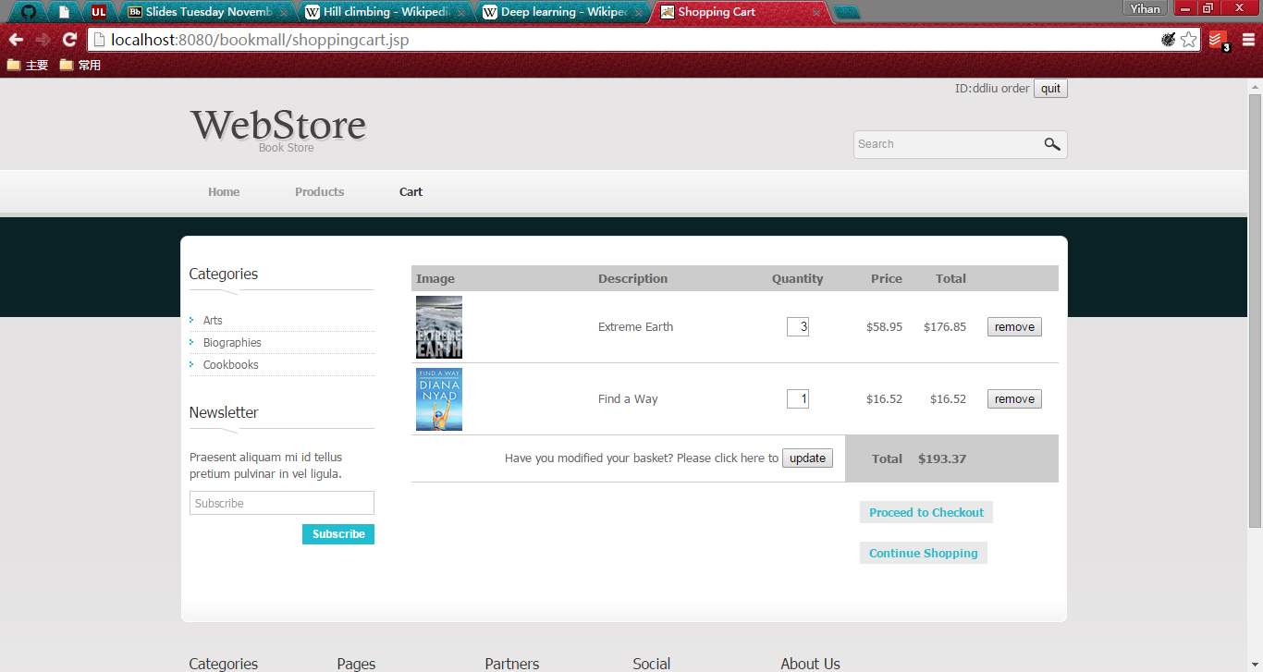

Checkout page: in this page, consumer can leave their contact information and they can select their payment method.

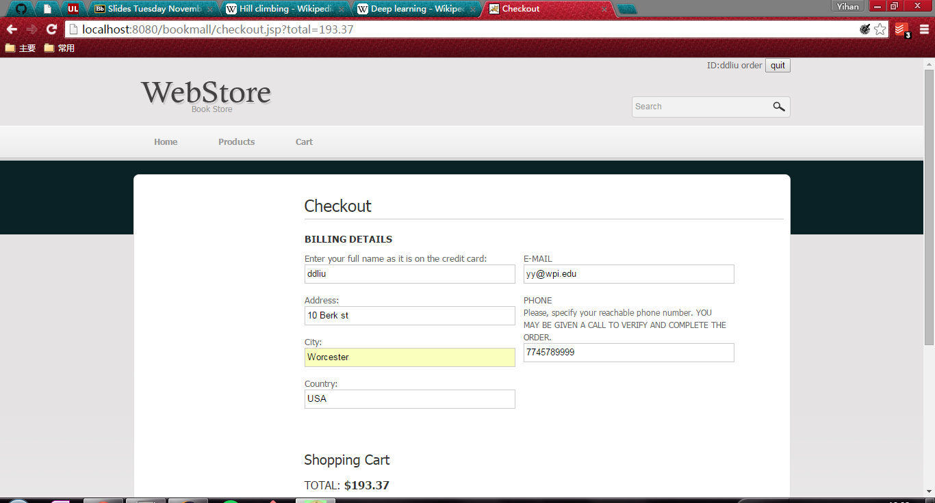

Orders page: In this page, consumer can check order history.

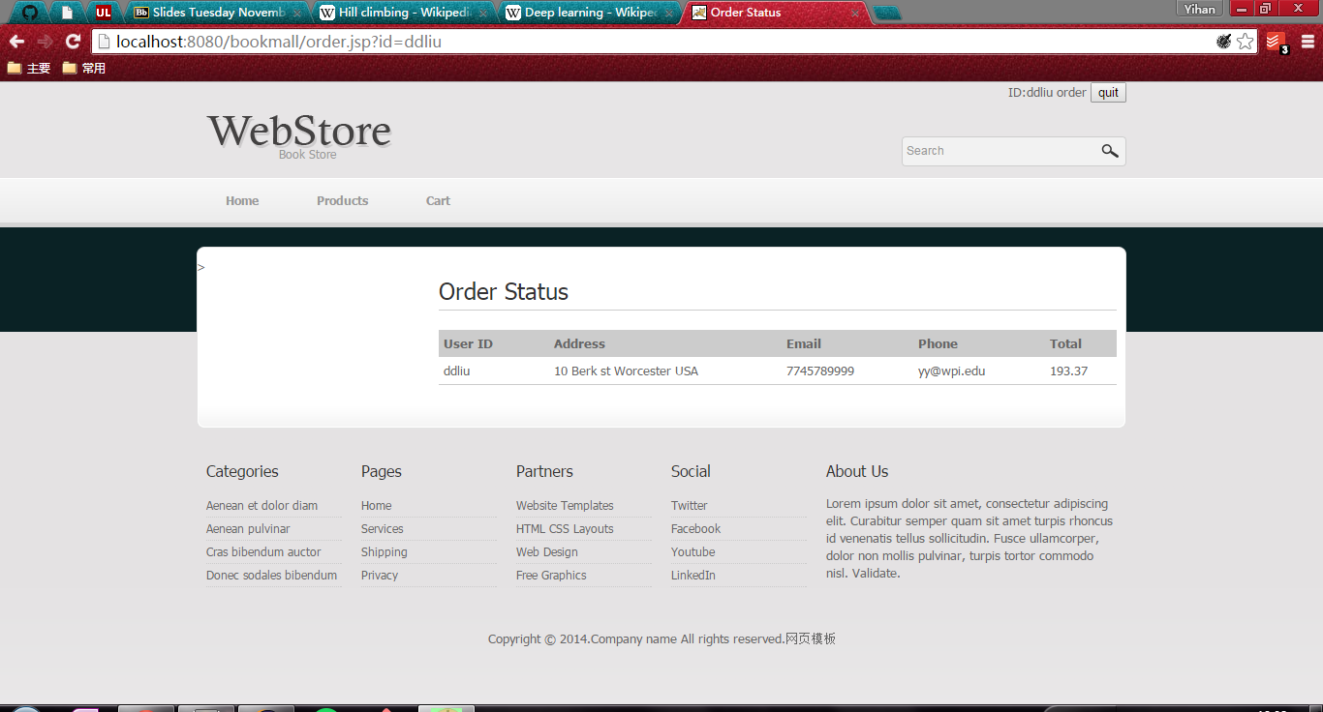

Search Page: You can search books by category and name

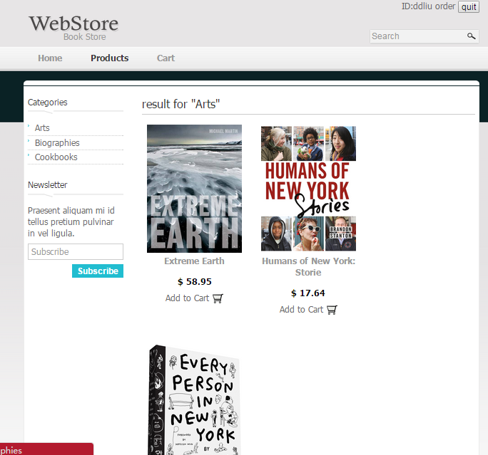

1. **Database Design**

We apply MySQL as our back-end database. According to the requirements of our book store, our schema includes three tables representing the category of books and detailed information of books, and detailed information users.

The category table only contains the category information where the books belong. It is the foreign key of book table, meaning a new book belonging to a new category can not be added before this new category is created.

Table 1. Category Table

|  |  |
| --- | --- |
| Column name | Type |
| category | varchar |

The book table contains all the detailed information of books, including book name, author, price, ISBN, the category the user belongs and cover images. The International Standard Book Number (ISBN) as a unique numeric commercial [book](https://en.wikipedia.org/wiki/Book) [identifier](https://en.wikipedia.org/wiki/Identifier) is the primary key of this table. Category is used as foreign key. The img attribute only contains the path of cover images and the images themselves are stored in local disk. Table 2. shows the detailed structure of book table.

Table 2. Book Table

|  |  |
| --- | --- |
| Column name | Type |
| name | varchar |
| author | varchar |
| price | float |
| ISBN | varchar |
| category | varchar |
| img | text |

The user table contains all the detailed information of registered users, including the username, password, phone and address. Among all these attributes, the username is unique for each user can used as primary key.

Table 3. User Table

|  |  |
| --- | --- |
| Column name | Type |
| username | varchar |
| password | varchar |
| phone | int |
| address | varchar |

Order table contains all the historical orders. All the attributes except for total are all referenced from user table.

Table 4. Order Table

|  |  |
| --- | --- |
| Column name | Type |
| username | varchar |
| address | varchar |
| email | Varchar |
| phone | Varchar |
| Total | float |

1. **Server**

Our web store is based on the MVC architectural patter in order to divide the representations of information presented to users or accepted from users. We used Java Servlet to implement the interaction between back-end and front-end and JavaBean to package project. Then by adopting JSP, we realize dynamic URLs. There are 3 main parts in our web application: user login, goods search and cart manager.

User login: we apply AJAX to create asynchronous web servlet. CheckUser to check if user has input the right id and password. If a user login in successfully, the session will remember the user id, which will show the user account information in other pages.

Book search: this part mainly has two kinds of way for searching. One is searching by goods name, the other one is searching by category.

Cart manager: By define a JavaBean class cart, a Dao class cartManager and 2 servlet classes addCart and processCart, using session to remember the information in cart, we realized a cart system which can update and remove goods in cart.

1. **Summary**

Online shopping system is a virtual store in which consumers can buy goods using a web browser. Comparing to shopping experience in conventional retail store, online shopping is very convenient without the limitation of locations and open and closed hours. Customers can get a wealth of product information, customer reviews and real-time service. In addition, customers are able to quickly seek out deals provided by many different vendors through price comparison services. Invented in 1979 and boomed after World Wide Web commercializing in 1990, online shopping system has huge commercial value. Only in Asia-Pacific, the sales increase over 30% per year and achieved over US$9.3 billion sales in Alibaba’s sites on peak online shopping day.

Our on-line shopping system is under B-S structure, based on MVC model, using Java Servlet, JavaBean, JSP, MySQL and AJAX to implement basic functions as user login, searching for goods and cart system.